

Actividad [#1] – [Relationships and Segments] [Ingles para los negocios]

Ingeniería en Desarrollo de Software

**Tutor: Fátima Fernández de Lara Barrón**

**Alumno: Manuel Enrique Ramirez Lopez**

**Fecha: 08/05/2022**

***Indice***

*Developing* 1

*Screenshots* 3

*Conclusion* 5

*Bibliography* 6

# *Developing*

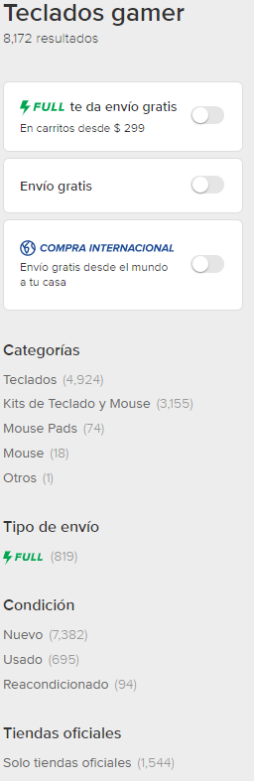***Context:***The company will try to solve the logistics of deliveries at the national level using the free market platform, with this it seeks to reach a large number of potential clients for the company which is offering personalized computer peripherals together with the importation of the same but that these do not they come to market officially in the country.

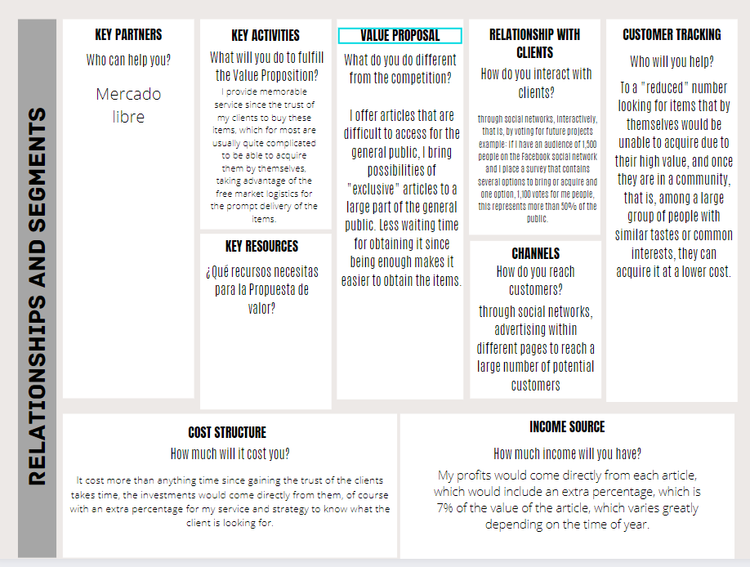

# *Screenshots*

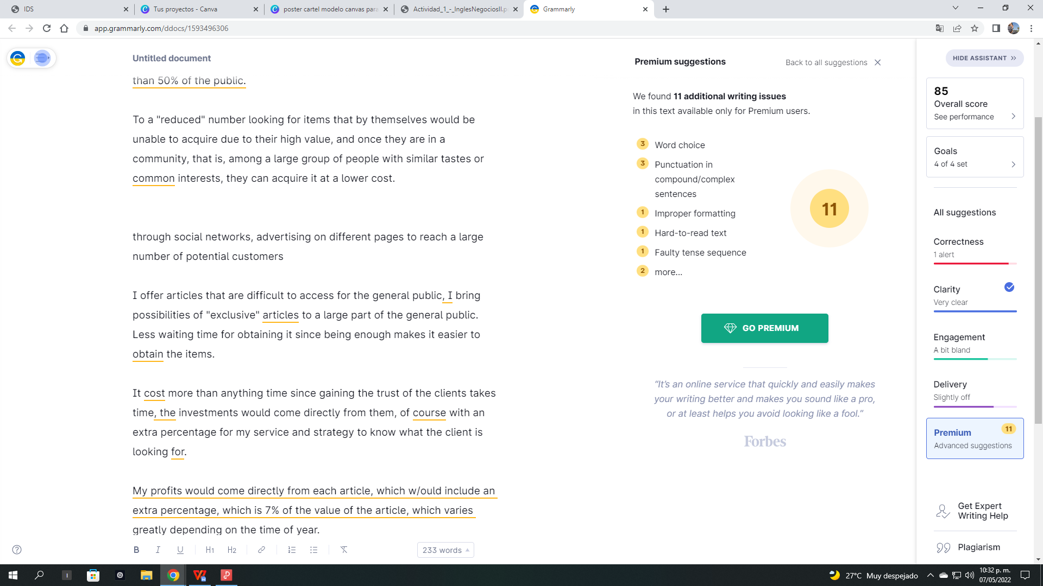

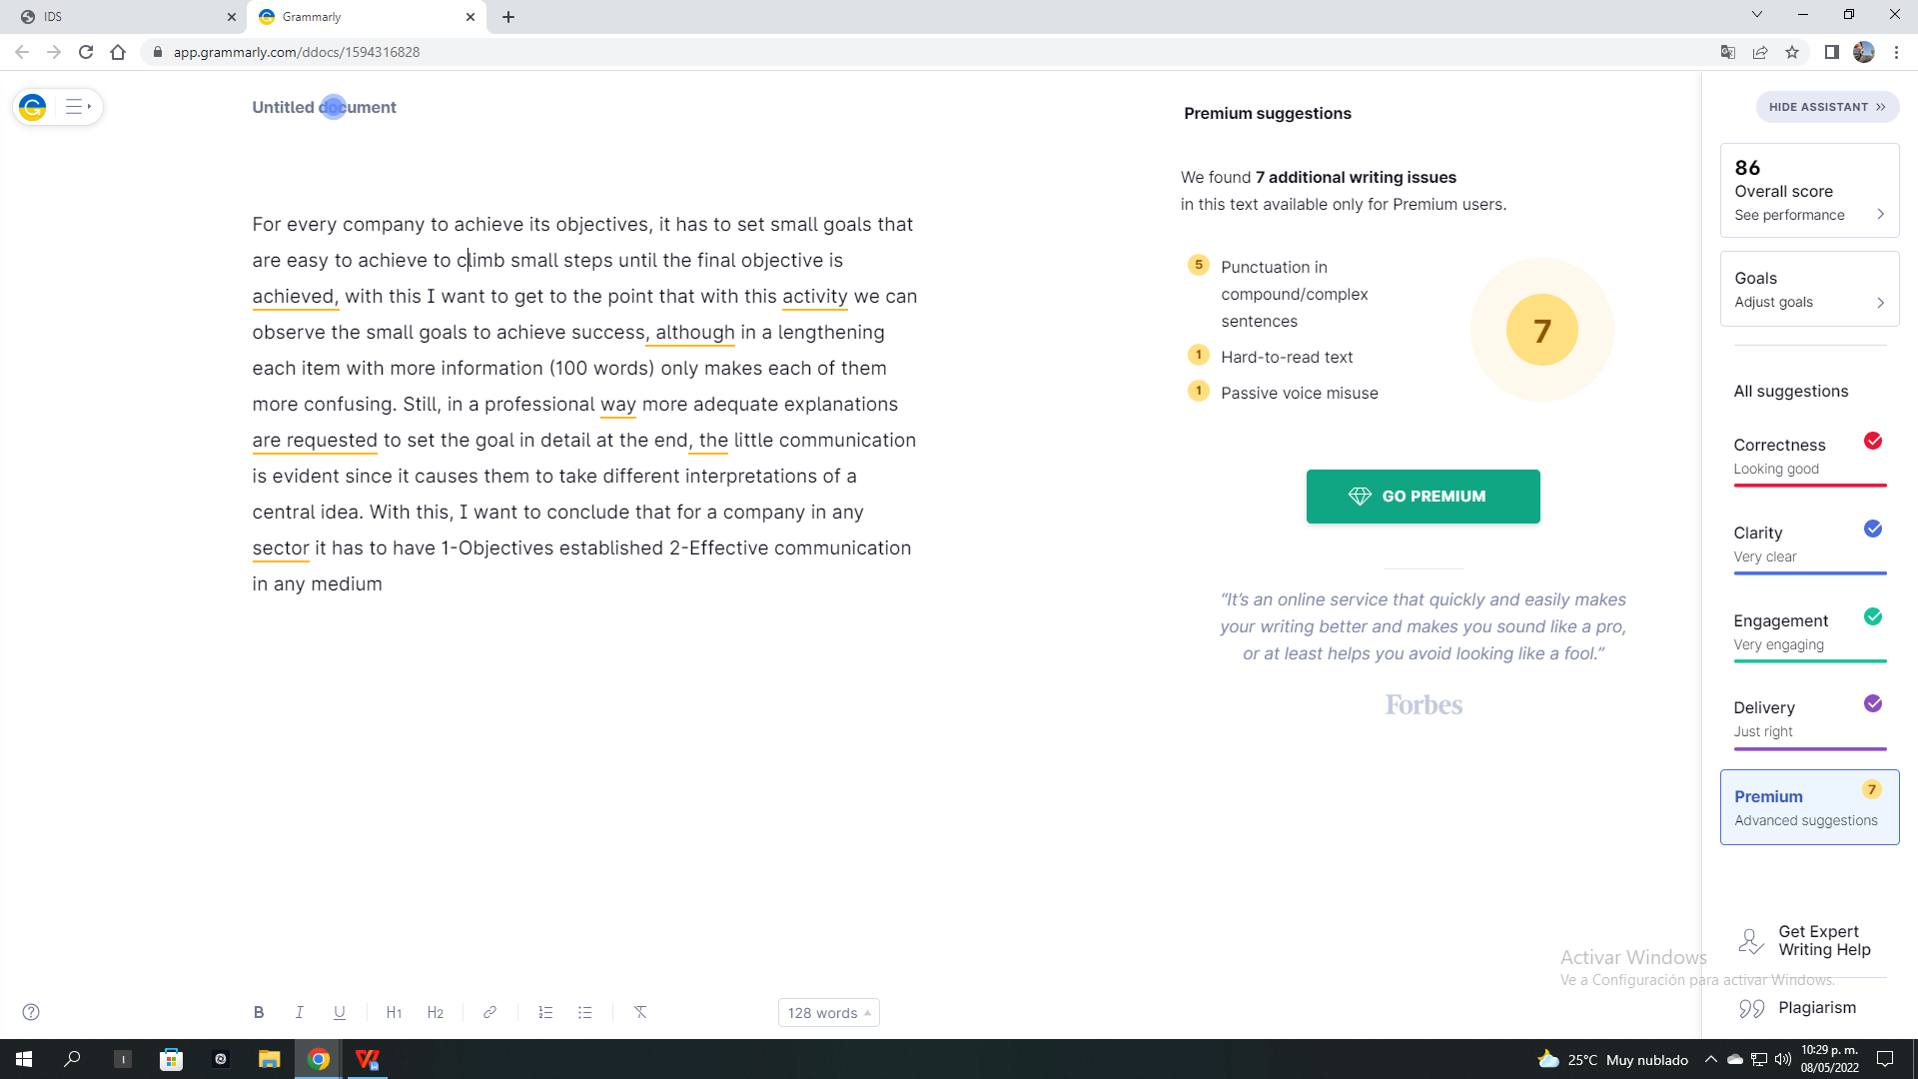

# *Conclusion*

For every company to achieve its objectives, it has to set small goals that are easy to achieve to climb small steps until the final objective is achieved, with this I want to get to the point that with this activity we can observe the small goals to achieve success, although in a lengthening each item with more information (100 words) only makes each of them more confusing. Still, in a professional way more adequate explanations are requested to set the goal in detail at the end, the little communication is evident since it causes them to take different interpretations of a central idea. With this, I want to conclude that for a company in any sector it has to have 1-Objectives established 2-Effective communication in any medium.

# *Bibliography*

Enrique Lopez. (2021). (se abre en una ventana nueva) poster cartel modelo canvas para negocio formal blanco y negro. 2022, de Privada Sitio web: <https://www.canva.com/p/templates/EAE7EZ9c4BY-poster-cartel-modelo-canvas-para-negocio-formal-blanco-y-negro/>